World Regional Geography Assignment: Name: Luke Pepin

**Story Maps of Global Places**

For our final activity, you will make a basic story map of a set of places, centered around a theme, that you are interested in. A story map in Google Earth consists of a set of places that center around a theme and/or create a narrative. In this case, you will just be placing three placemarks, but the principle for making a full storymap just involves multiple locations that tell a story. You will use the power of Google Earth Pro to mark a site of interest, research that location, and create a placemark, and then follow this process for two more locations.

The first step in this assignment is to choose a theme for your storymap that you are interested in. Themes could include:

* World heritage sites
* Race and ethnicity
* Economic development
* Labor, economics, and the informal economy
* Tourism
* Human Migration
* Economically valuable natural resources
* Preserved spaces and/or animal habitats
* Climate change
* Climate zones
* Tectonics
* Natural Landscapes

Identify three locations that exemplify your theme and build your storymap around those locations.

# As an example, if you chose UNESCO World Heritage Sites as your theme, you would go to the UNESCO World Heritage site list at <https://whc.unesco.org/en/list/> to find locations that might relate to each other such as Magnificent Waterfalls. From here, you might decide on Jiuzhaigou Valley Scenic and Historic Interest Area in China, Mosi-oa-Tunya/Victoria Falls in Zambia/Zimbabwe, and Iguacu Falls in Brazil/Argentina. You can use the interactive map or one of the other tools to identify a site of interest.

Next you should do some research on your site. Why was it designated as a World Heritage Site (see list from the Powerpoint), what threats (if any) confront the site, and what makes this site special or interesting to you? Write up a brief document answering each of these questions and including a picture of the site (this can be from the internet or the UNESCO site). If your theme is something other than a World Heritage Site, include this information why it is important, threats it faces, and what makes it special to you. Please include URLs for your information

Now you should create a Placemark of your site with your information (see instructions below).

When you are done, save your .kmz file by selecting it and saving it locally (right click in PC), then submitting it to HuskyCT, along with copying the text you wrote into the text box for the assignment on HuskyCT.

- Make a placemark using the “Add Placemark” button in Google Earth and clicking on your location (it helps to zoom into your location first). This will create a new placemark in the bar on the left (here is an example of the Austin Building at UConn where my office is)

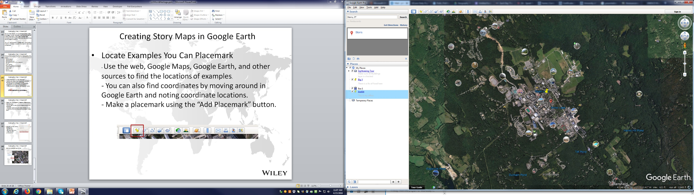

* Organize your text, photos and diagrams

- Copy your write-up into the text box

- Add links and web images (URLs)

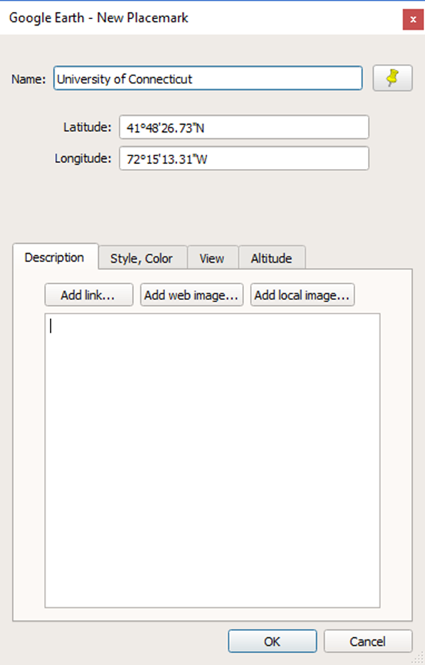

* Save your placemark as a KMZ file

